标题：Android Motherboard Onboard A20n CPU with LVDS
关键词：Android Motherboard ,Android SBC,Motherboard Android

ZC-A20N Motherboard,Very Small only 120*120mm,Onboard CPU A20
1GB RAM,8GB Flash.With 1*RJ45,WIFI,VGA and HDMI.
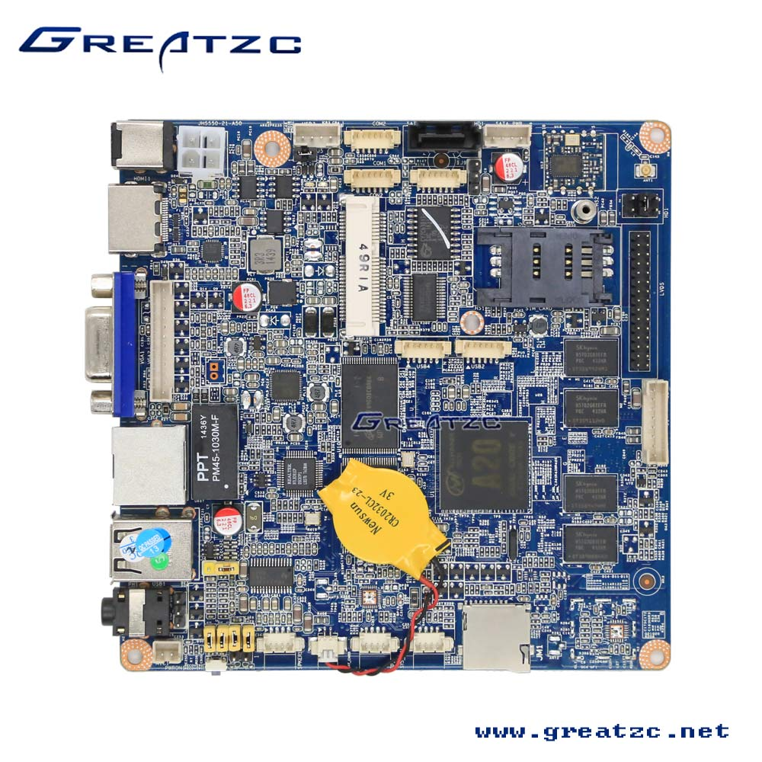
Main Features:
1.Onboard CPU A20,1GB RAM,8GB Flash.
2.Onboard Network Card,Onboard WIFI.
3.With VGA and HDMI Ports.
4.Fanless Design,Size is only 120*120mm.
5.Very Suitable For Embedded Advertising

ZC-A20N Motherboard Specification
CPU | A20 CPU
OS | Android 4.2 Default
Graphics Card | CPU Integrated
RAM | 1GB Default.
Flash | 8GB Default
Network Card | Onboard 1*100M Network Card
WIFI | Onboard WIFI
AUDIO Card | ALC662 Chip
RTC | With RTC Default
Expansion Slot | 1*Mini PCI-E,Support USB+PCIE Signal  1*SIM Card Slot
Rear Panel I/O | 1*DC12V  1*HDMI  1*VGA  1*RJ45  2*USB  1*Audio Out
Internal I/O | MIC-IN  SPKER  2*SYS_FAN  SD Card Slot  LVDS 30PINS  LVDS Backlight  SATA Slot  SATA PWR  Micro SD  COM1  COM2  ATX 4PINS  USB2  USB3  USB4
FAN | No,Fanless
Power Supply | DC-12V
Size | 120mm*120mm

